**Sports News Site**

**Zyad Mohamed Mansour(Leader) 184823 zyad184823@bue.edu.eg**

**Salma Tharwat Atef 180425 salma180425@bue.edu.eg**

**Doha Mohamed Ibrahim 181528** [**doha181528@bue.edu.eg**](mailto:doha181528@bue.edu.eg)

**The 4th member (Rawan) left the university**

**Wireframe for Home and all page except the following**

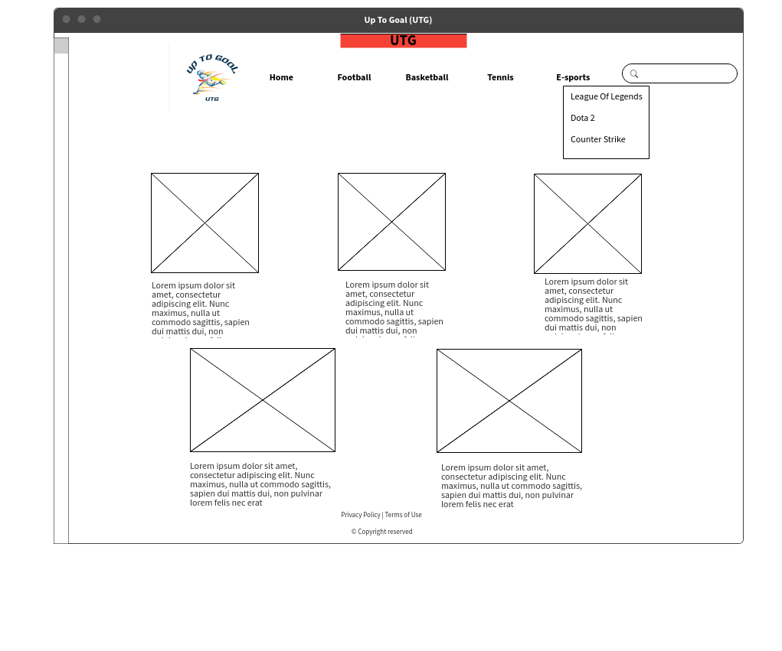

**Wirframe for About Us**

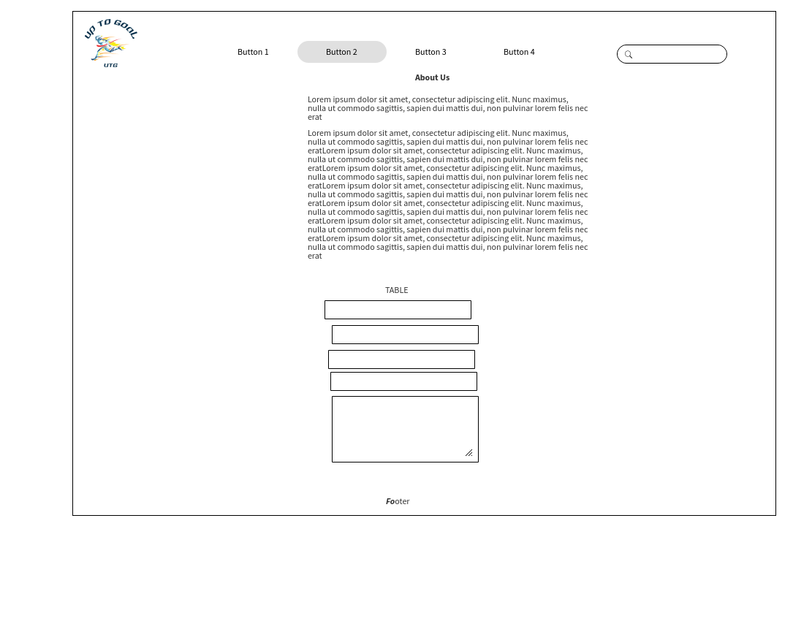

**Wirframe for Basketball and Football**

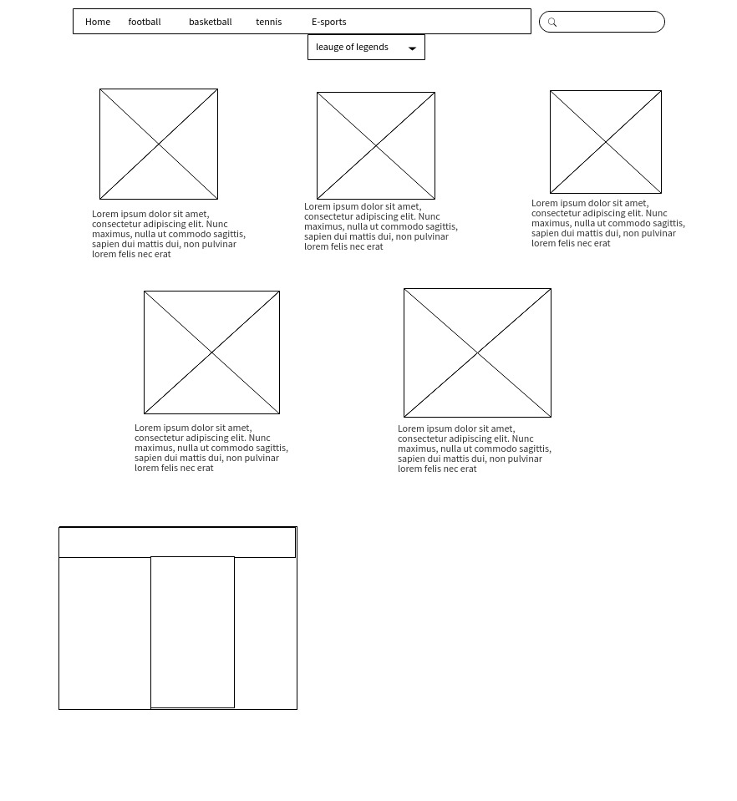

**Sitemap**



**There was a mistake on the previous sitemap (corrected)**

**Screenshots**

**___________________________________________**

**Home(Zoomed out )**

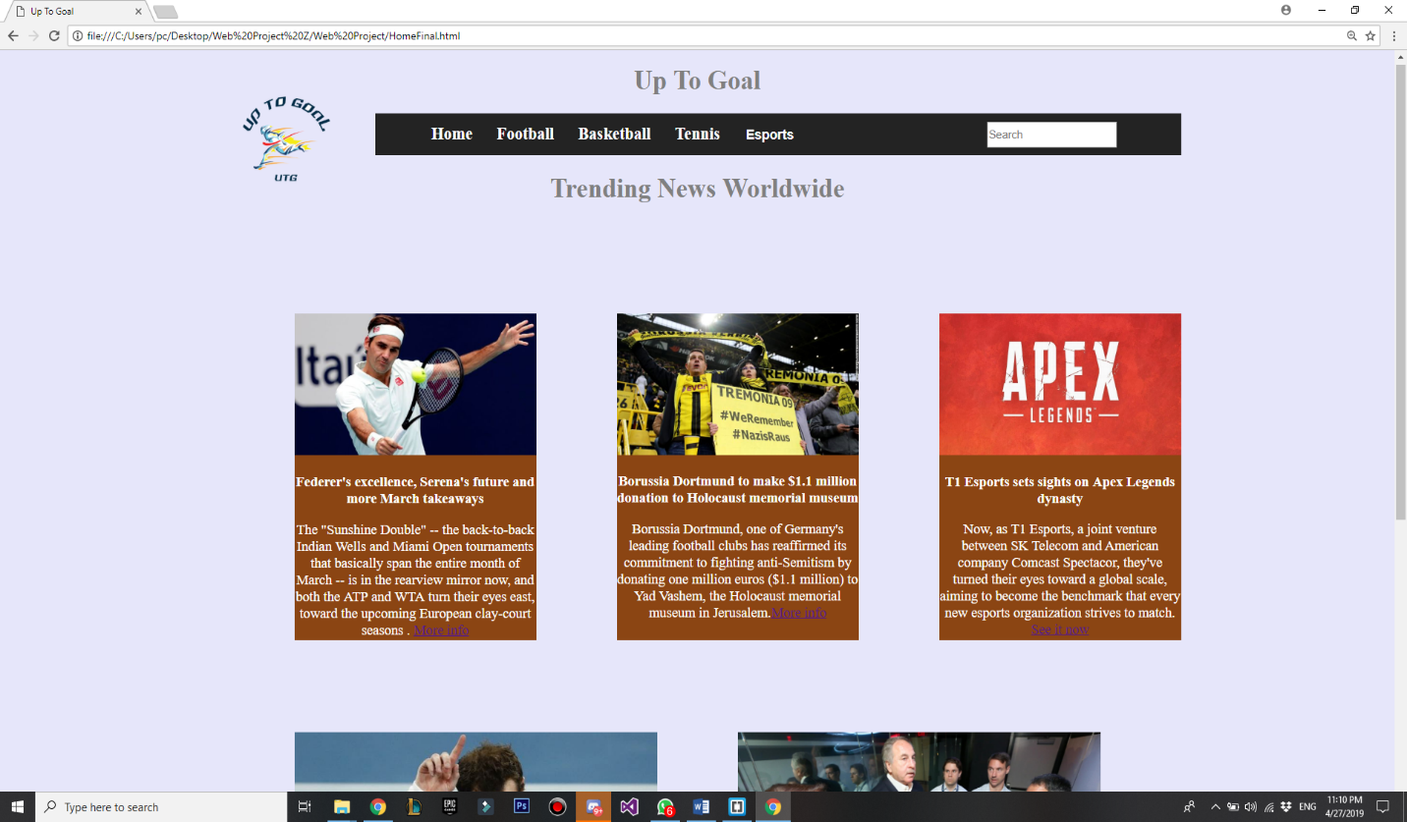

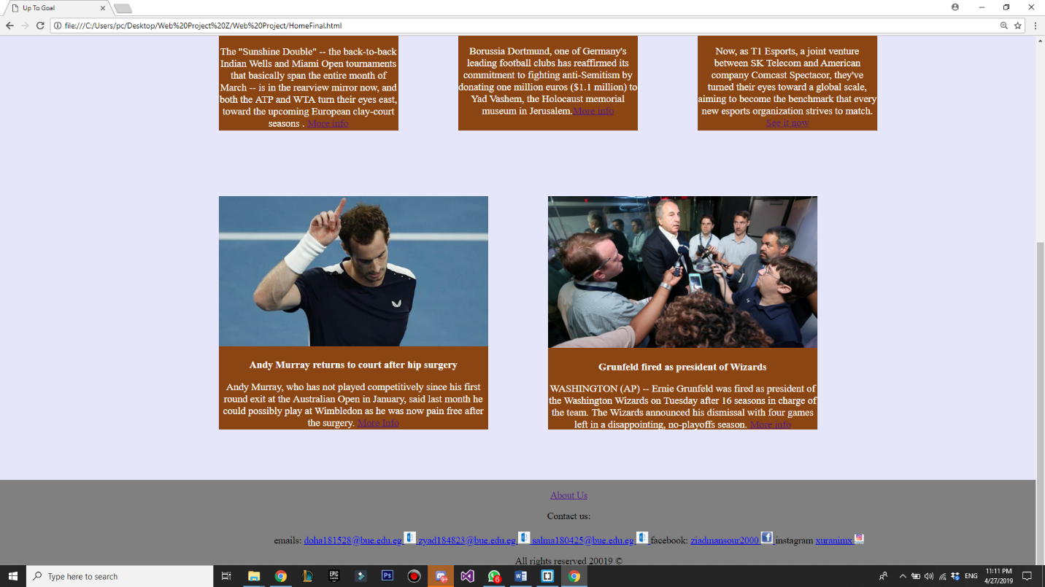

**Football(Zoomed out )**

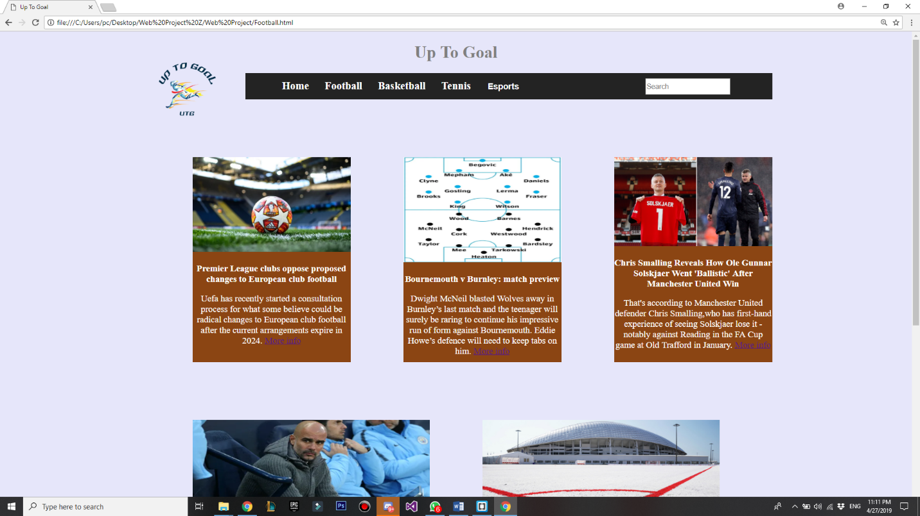

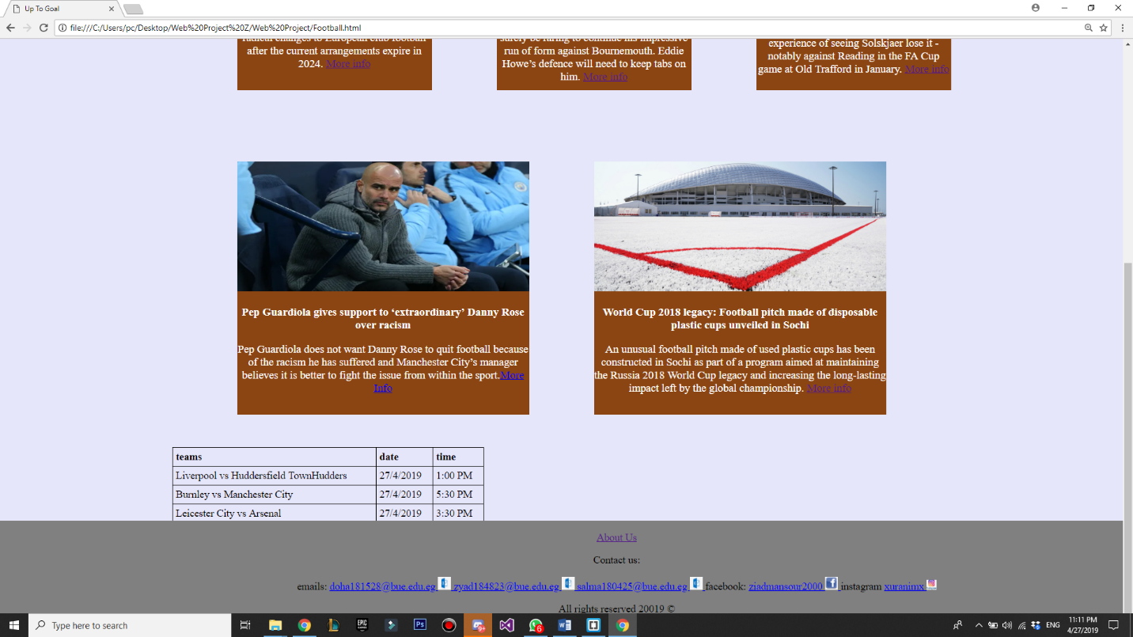

**Basketball(Zoomed out )**

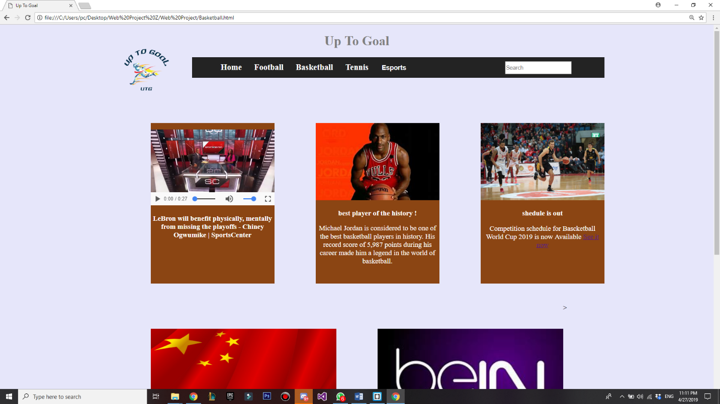

**Tennis(Zoomed out )**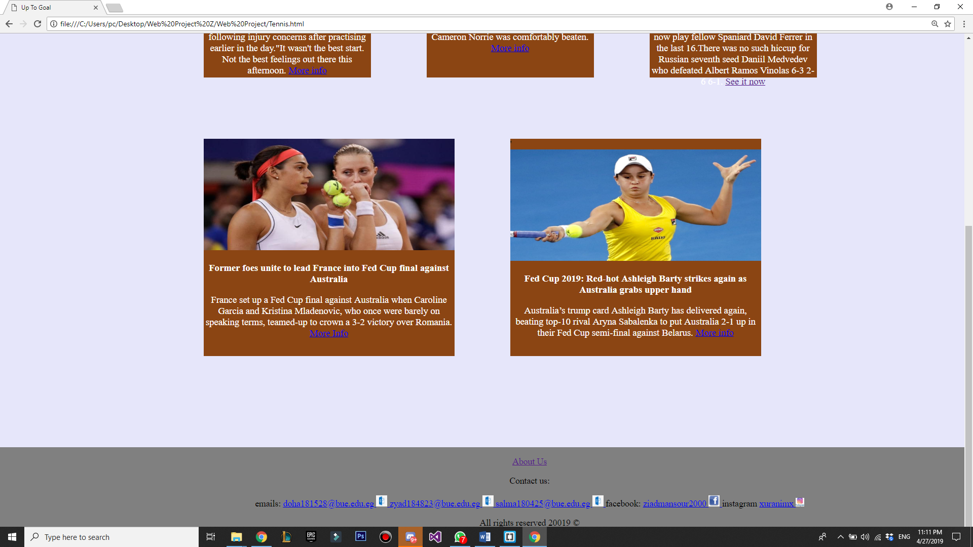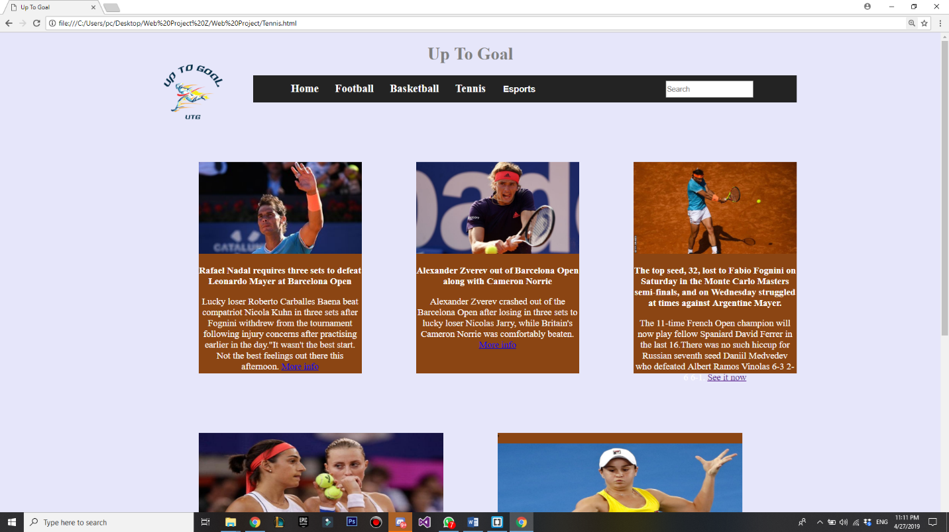

**LeagueOfLegends(Zoomed out )**

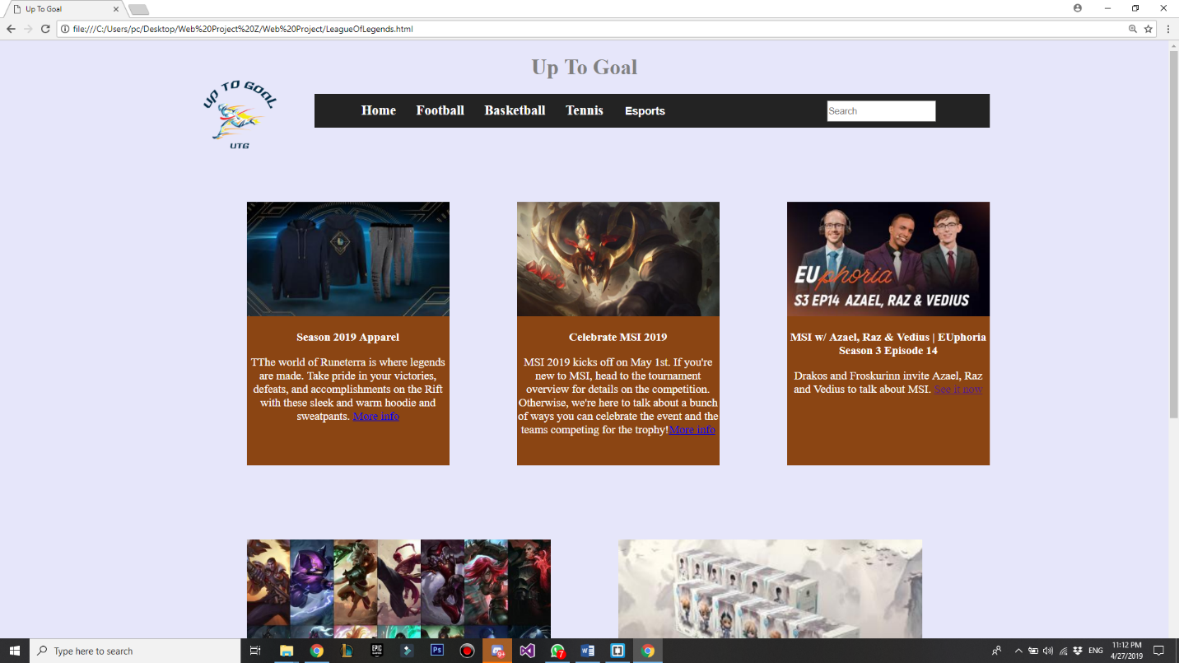



**Dota 2 (Zoomed out )**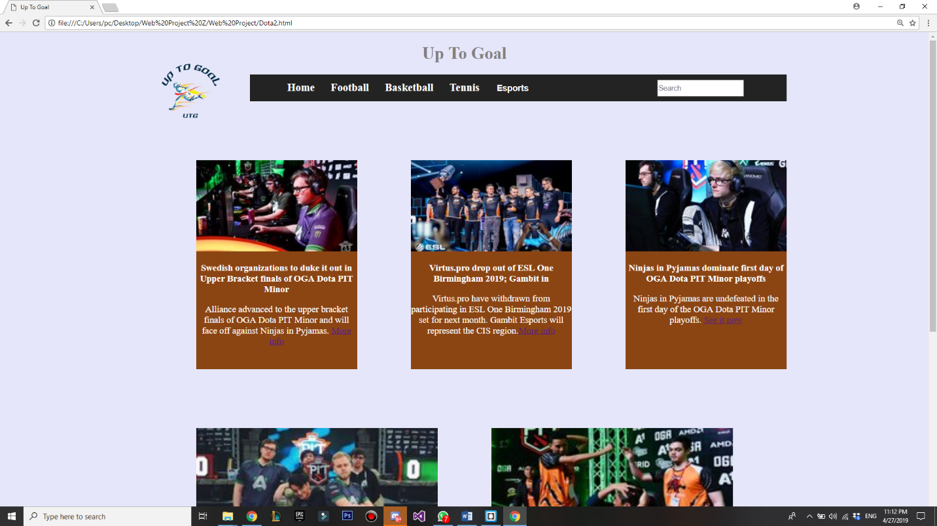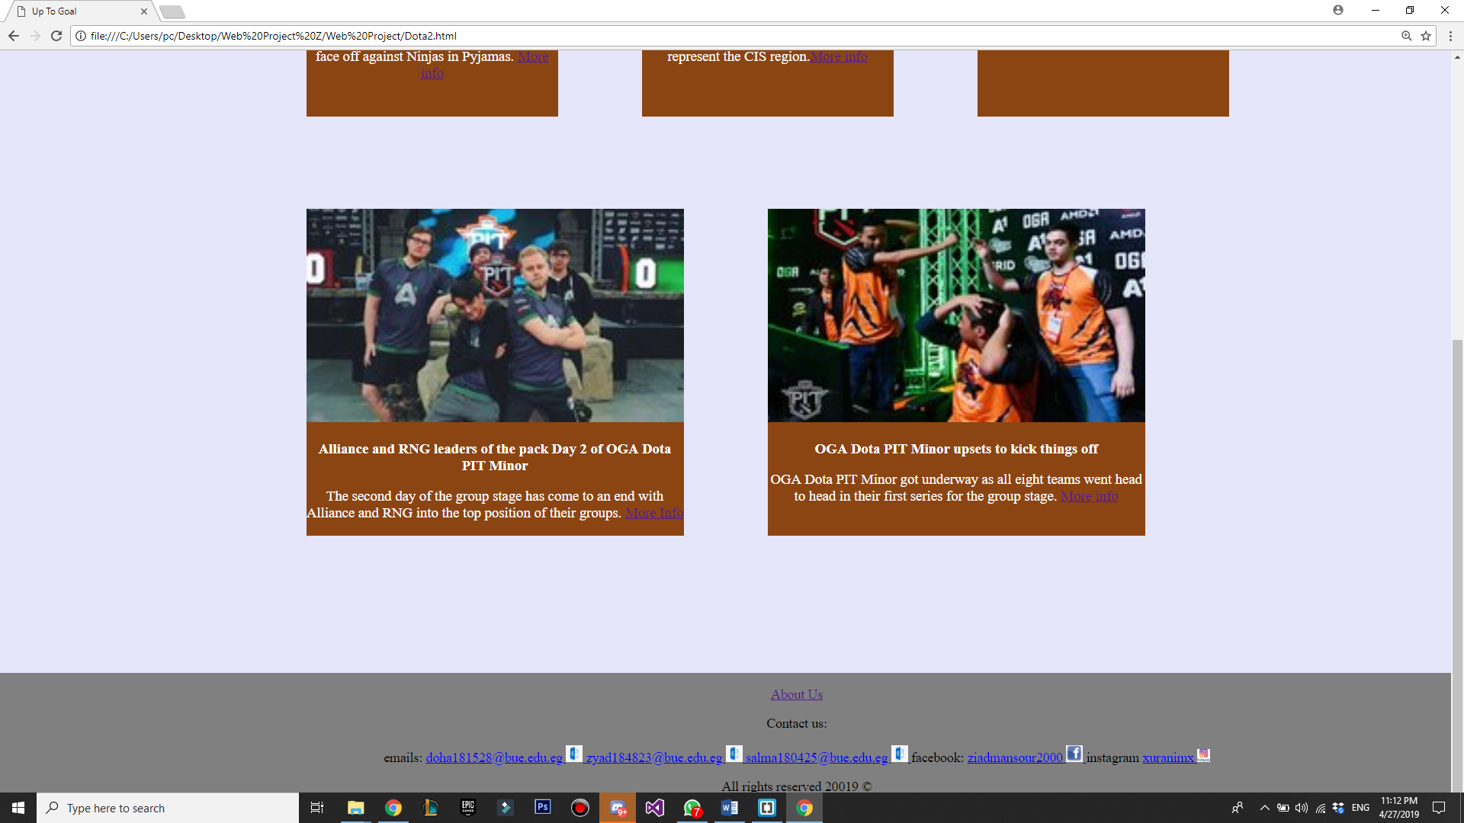

**Counters Strike (Zoomed out )**

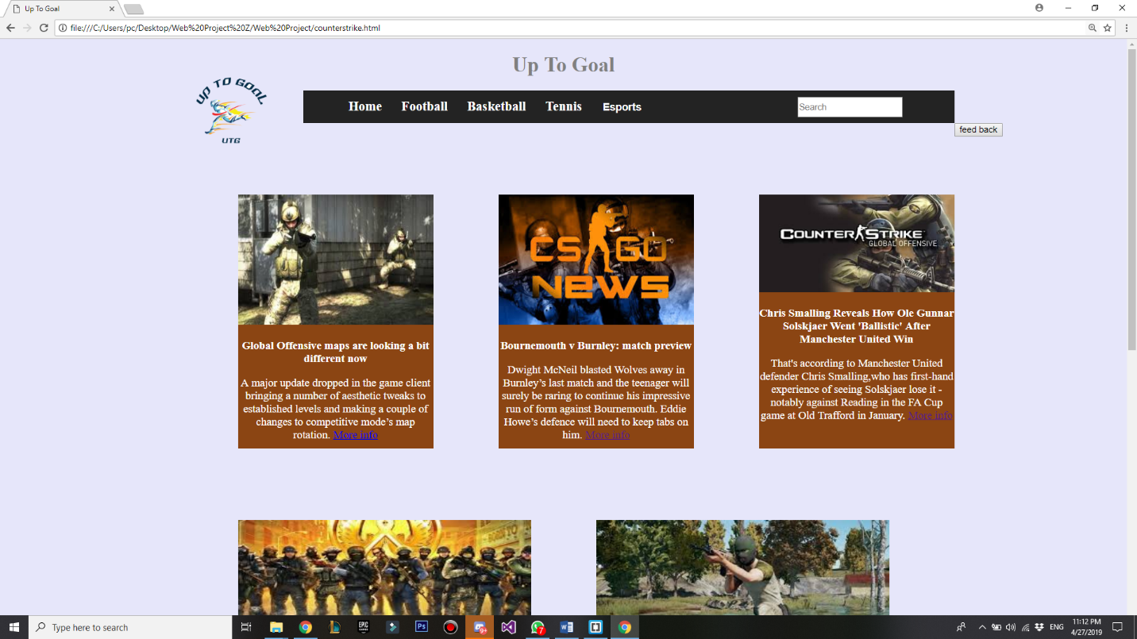



**Site Report**

When making the website “up to goal” our main objective was to create a platform that contained a diverse variety of supports, that’s why we decided to incorporate E-sports. We wanted a place where sport enthusiasts could read trending news about their favorite sport but also be able to give us feedback and share their own news. Our target demographic that we kept in mind while creating this site is males ages ranging from 12 to 50 but we also wanted our site to be please to people of all genders and ages. we want to keep all of our site users up to date with numerous types of supports hence the name “up to goal”. By allowing the users the option to give us feedback and to share their own news creates an interactive community and environment that we aim for. the reason we chose to add E-sports in to our news website is because as technology advances at a rapid rate we must begin to accept that it holds a significant part in our daily lives and that online gaming is now considered a highly competitive sport. In our website we do not only provide daily trending sports news but also upcoming support matches including the teams playing, the date, and the timing of the match. The information we acquire is through reliable and unbiased sources so that we can ensure that our users get real untainted information. to concluded, our website is about providing diverse reliable information to our users about a number of sports that range from physically done sports to E-sports ; we also allow our users to send us feedback via feedback forms and news through other forms.

**W3C Validation**

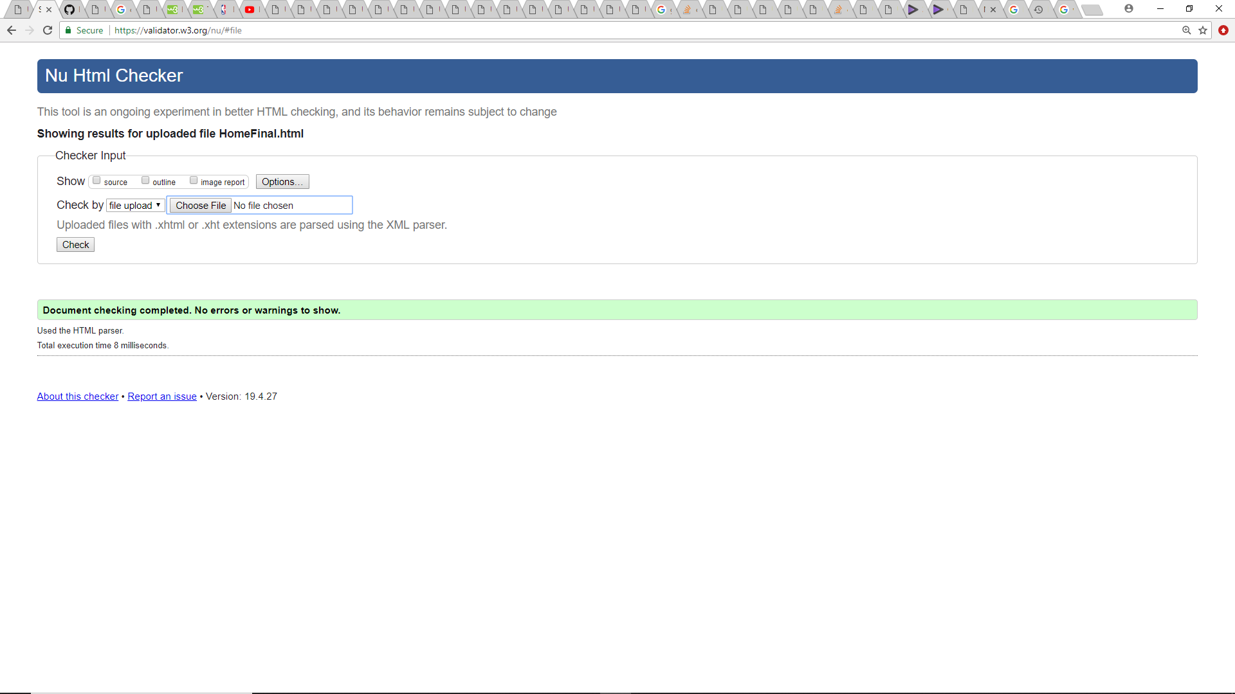

Every Single page Is checked for HTML and there is no single error on all the pages 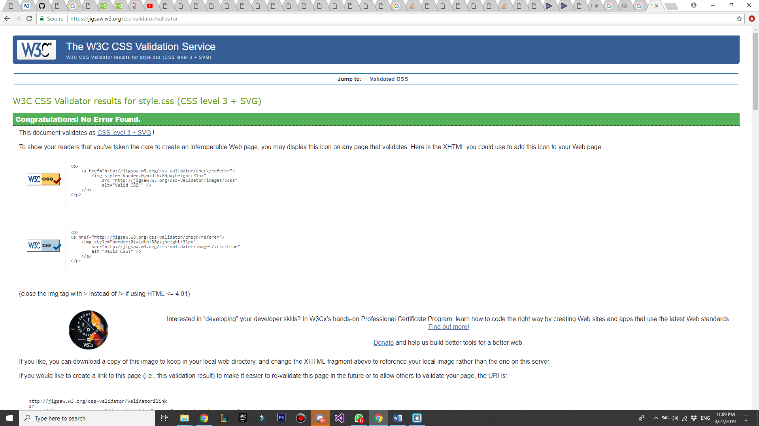

**There is not a single error on the CSS validation .**